- Introduction :

  - Project Overview: In the modern retail landscape, where competition is intense and consumer attention is fragmented, product placement strategies can significantly influence customer purchasing behavior. Businesses often invest in promotional activities, optimized store layouts, and targeted marketing, but lack the tools to evaluate their real impact. This project aims to bridge that gap using data visualization.
The project titled “Strategic Product Placement Analysis Using Tableau” focuses on uncovering insights from structured retail data that includes variables like product positions (e.g., end caps, aisles), sales volume, price comparisons, promotional status, customer demographics, and foot traffic levels.
By utilizing Tableau, we transform raw spreadsheet data into interactive dashboards that help stakeholders answer key questions:
      - Which product placements drive the highest sales?
      - How do promotions and traffic zones affect buying behavior?
      - What role do demographics play in conversion?
The project leverages visual storytelling and filters to help non-technical users — such as retail managers and marketers — explore patterns in a self-service, visually intuitive format. The solution provides a 360-degree view of product performance across variables that were previously hard to analyze together.

  - Purpose : The purpose of this project is to enable data-driven decision-making in retail environments by visualizing and analyzing how various factors such as product placement, promotions, customer demographics, foot traffic, and competitor pricing impact overall sales volume.
Retail companies often struggle to interpret raw data stored in spreadsheets, which limits their ability to respond quickly to changing customer behavior or optimize their store layouts. This project addresses that gap by developing an interactive Tableau dashboard that transforms this raw data into meaningful and actionable insights.
Through this dashboard, stakeholders can:
      - Visually compare product performance across different store areas (e.g., aisle vs. endcap).
      - Analyze the effectiveness of promotional strategies across demographic groups.
      - Understand how traffic zones influence buying decisions, and adjust layouts accordingly.
      - Compare pricing against competitors to better position products for conversion. The project serves not only as a tool for analysis but also as a strategic aid for marketing, merchandising, and operations teams. It simplifies the decision-making process by:
      - Providing custom filters (like demographics and traffic level),
      - Enabling quick comparisons between different positioning strategies,
      - And delivering visual stories that present findings in a sequential, understandable way. Ultimately, the purpose of this solution is to empower retail organizations with a scalable, visual analytics platform that improves sales performance, enhances the shopping experience, and leads to smarter marketing and placement strategies.

- IDEATION PHASE :
  - Problem Statement : Retailers face a common yet critical challenge: they lack visibility into how product positioning affects consumer behavior and sales performance. While companies invest in promotions, layout design, and pricing strategies, they often make these decisions based on intuition or historical assumptions rather than real, current data insights.
The absence of interactive visual tools makes it difficult for retail teams to explore how variables like product category, traffic levels, promotions, and customer demographics intersect to influence sales. As a result, businesses may place high-performing items in lowtraffic zones, run ineffective promotions, or fail to engage key demographic segments — all of which lead to missed sales opportunities and inefficiencies in floor planning.
Traditional reporting tools like spreadsheets:
      - Do not provide real-time interactivity
      - Cannot offer multi-variable analysis (e.g., how promotions affect seniors in high-traffic areas)
      - Require manual exploration and time-consuming analysis
This problem is further amplified in large retail chains with thousands of products and multiple store locations. Without an integrated visualization system, it's nearly impossible to optimize placement strategies consistently across all sites.
Hence, there is a strong need for a solution that:
      - Visualizes the impact of strategic product positioning
      - Allows for interactive exploration of sales data
      - Supports quick, data-backed decisions by retail stakeholders
This project aims to solve that problem by developing an interactive Tableau dashboard that connects business teams directly to their data in a visual, actionable format.
  - Empathy Map Canvas :
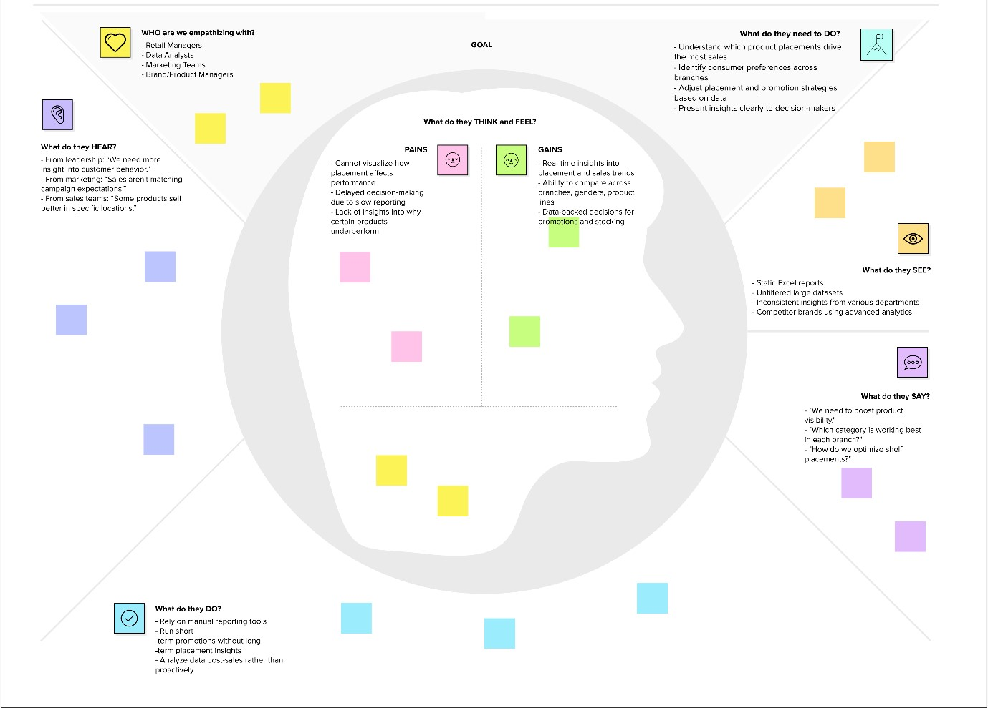

  - Brainstorming :
    - Team Collaboration and Approach : To begin our project, our team conducted a collaborative brainstorming session to explore various ways to approach the problem of unclear product placement effectiveness in retail. We gathered insights by analyzing the dataset Product Positioning.csv and listing key attributes such as:
        - Product Position (e.g., aisle, end-cap)
        - Foot Traffic (low, medium, high)
        - Promotion (yes/no)
        - Consumer Demographics (e.g., young adults, seniors)
        - Sales Volume
        - Product Category
We discussed how these dimensions could influence customer buying behavior and what visuals would most effectively communicate the results to stakeholders like retail managers, marketers, and business analysts.

    - Ideas Generated and Grouped by Category:
Idea |  |  | Category
Compare sales volume by product position (aisle vs end-cap) using bar chart |  |  | Placement Strategy
Show conversion or drop across traffic levels using funnel chart |  |  | Traffic Analysis
Use donut chart to visualize promotional vs. nonpromotional product performance |  |  | Promotion Analysis
Create a highlight table for demographics vs. product category sales |  |  | Demographic Mapping
Visualize price gap vs. sales performance using calculated field |  |  | Pricing Strategy
Add filters for foot traffic, demographics, seasonal flag |  |  | Interactivity
Create a word cloud of top-selling product categories |  |  | User Engagement
Use waterfall chart to show contribution of each category to total sales |  |  | Financial Insight
Add a Tableau Story to guide business users through analysis in stages  2.3.3. Prioritization: |  |  | Storytelling/Presentation
Priority Idea |  |  | Reason
Bar Chart for Product  High  Position vs Sales |  |  | Core to solving the project’s main problem
Donut Chart for Promotion  High  Impact |  |  | Simple and clear to stakeholders
 | Priority | Idea | Reason
 | High | Highlight Table for  Demographics | Helps target customer segments more precisely
 | High | Filters for Category,  Traffic, and Promotion | Essential for interactivity
 | Medium | Funnel and Waterfall  Charts | Adds depth to financial and behavioral insight
 | Low | Word Cloud and  Storyboard | Adds polish and storytelling but not critical to logic

- REQUIREMENT ANALYSIS :
  - Customer Journey map : The Customer Journey Map helps visualize the enduser’s experience from problem identification to solution adoption. For this project, our primary users are retail managers, marketing analysts, and store planners who want to improve sales using data-driven product placement.

Solution /
User Pain Points
Stage User Action Feature in
Experience / Barriers Dashboard
Awareness | Notices inconsistent sales patterns and underperformin g promotions | Frustrated by lack of visibility into what's working
Depends on Dashboard
static reports reveals sales
or gut by position, feeling promo, traffic
Consideratio n | Explores sales data in Excel and tries to isolate patterns manually | Overwhelme  d by data complexity and too many variables
Excel not Tableau
suitable for visualizations
multi- simplify and
dimensional organize analysis insights
Adoption | Uses dashboard filters to view sales by product line and foot traffic | Feels in control, can explore data freely
Unsure how Filters for to analyze traffic, interactions demographics between , promotions, variables etc.
Solution /
Stage | User Action | User  Experience | Pain Points  / Barriers | Feature in  Dashboard
Insight | Discovers that promotions in high-traffic zones improve sales among youth | Gains insight that can be turned into strategy | Hard to validate hypothesis without historical view | Visual trends and highlight tables clarify patterns
Action | Repositions products and targets promos based on dashboard findings | Confident in decisionmaking | Needs support to present results to leadership | Dashboard  storytelling feature and export capability
Feedback | Shares dashboard with colleagues and adjusts based on results | Feels empowered by team alignment | May want deeper segmentatio n or automation | Dashboard is scalable and can be enhanced  later
3.2 Solution Requirement:
Functional Requirements: These describe what the system must do — the features and capabilities that are essential to building your Tableau dashboard for product placement analysis.
FR Functional Requirement
Sub-Requirement (Story / Sub-Task)
No. (Epic)
User uploads the Product Positioning.csv dataset
FR-1 Upload Data
into Tableau
Convert data types, clean missing values, rename
FR-2 Data Preprocessing
fields
FR  No. | Functional Requirement  (Epic) | Sub-Requirement (Story / Sub-Task)
FR-3 | Visualize Product Performance | Create bar chart showing sales by product position
FR-4 | Analyze Promotion Effectiveness | Build donut chart comparing sales for promotion = Yes vs No
FR-5 | Evaluate Traffic Impact | Funnel or area chart visualizing sales by foot traffic levels
FR-6 | Demographic Sales Comparison | Highlight table showing sales volume by consumer demographics
FR-7 | Visual Storytelling | Build a Tableau story combining visuals to explain key insights
FR-8 | Interactive Filters | Add filters for Promotion, Traffic Level, Demographics, and Category
FR-9 | Export Dashboard | Allow users to export visuals to PDF or PNG for reporting purposes
Non-Functional Requirements: These define how the system should perform, covering quality standards like performance, usability, and scalability.
NFR  No. |  | Non-Functional  Requirement |  | Description
NFR-1 |  | Usability |  | The dashboard should be intuitive and easy for non-technical users to navigate
NFR-2 |  | Reliability |  | The visuals must consistently reflect correct results when filters are applied
NFR  No. | Non-Functional  Requirement |  | Description
NFR-  3 | Performance |  | Dashboard should load and respond within 5 seconds for  1000+ rows
NFR-  4 | Availability |  | The dashboard should be accessible via Tableau  Public or PDF anytime
NFR-  5 | Scalability |  | Must support addition of new product categories or more rows without redesign
NFR-  6 | Security |  | Dataset is handled locally or via secure sharing; no personal data is exposed
3.3 Data Flow Diagram: A Data Flow Diagram (DFD) shows how data moves through your system — from input to final output — across different components. This project processes a CSV dataset through Tableau to produce interactive dashboards for business decision-making.
Level 1 DFD – Detailed Process Flow:
 |  | Process Component | Description
1 |  | Data Input | User uploads Product Positioning.csv to Tableau
2 |  | Data Cleaning &  Formatting | Missing value check, column type conversion, column renaming
3 |  | Calculated Fields | Fields like Price Gap, Sales Category, % Difference
4 |  | Visualization Engine | Tableau sheets and dashboards created using multiple chart types
 | Process Component |  | Description
5 | Filters |  | Applied on Promotion, Traffic, Demographics, Product  Category
6 | Dashboard Assembly |  | All sheets combined into one interactive dashboard
7 | Storytelling Mode |  | Tableau story created to walk stakeholders through key insights
8 | Output |  | Users view or export dashboard results (PDF, image, or shareable link)

3.4 Technology Stack: This section outlines the tools, technologies, and components used to build and deploy the solution. It includes both the architecture layers and the technology choices for your project.
- Technical Architecture (3-Tier Design)
Layer | Component Description
Presentation Layer | The final Tableau Dashboard UI, visible to users. Includes interactive filters and visuals
Application Layer | Tableau Engine responsible for creating calculations, visual logic, and rendering visuals
Data Layer | Raw dataset: Product Positioning.csv stored locally or on Google Drive

- Components & Technologies Used
S.
Component Description Technology Used
No
Tableau Dashboard with visual Tableau Public /
- User Interface
and filter components Desktop
Data cleaning, type conversion, Tableau, Optional:
- Data Processing
and calculated fields Python/Pandas
Dataset stored and imported into Local File System /
- File Storage
Tableau Google Drive
Visualization Tableau Visualization
- Chart rendering and interactivity
Engine Engine
Story Tableau Story feature for
- Tableau
Presentation sequential insights
Export & Export reports in PDF/Image Tableau Public / PDF
6
Sharing formats; public dashboard access Export

C. Application Characteristics
Feature |  | Description | Technology Used
Open Source Frameworks |  | Tableau Public is freely accessible, optional use of Python (Pandas) | Tableau Public, Pandas
Security |  | Controlled data sharing via Tableau Public permissions and Google Drive | Tableau Share Settings
Scalability |  | Can support more data rows, product lines, or new categories easily | Tableau Extract Engine
 | Feature | Description |  | Technology Used
 | Availability | Hosted via Tableau Public or downloadable as a file for 24/7 access |  | Tableau Public
 | Performance | Fast loading for up to 1000+ rows with live filters and dashboard response |  | Tableau (Live / Extract)

- PROJECT DESIGN:
  - Problem Solution Fit:
The Problem
Retailers often struggle with making data-driven decisions about product placement, promotions, and pricing strategies. While they collect vast amounts of sales data, most of it remains underutilized due to:
    - Lack of interactive tools for visual exploration
    - Difficulty in comparing multiple variables like foot traffic, promotions, and demographics
    - Dependence on static reports and gut-feeling decision-making
As a result, businesses may miss key opportunities to optimize store layouts and promotional campaigns, leading to reduced conversion rates and inefficient use of retail space.

The Solution
This project proposes a fully interactive Tableau dashboard that transforms flat, static sales data into dynamic visuals. The dashboard allows users to:
    - View and compare sales volume by product placement
    - Analyze the impact of promotions across different traffic zones and demographics
    - Explore the gap between own pricing and competitor pricing
    - Identify which product categories and customer segments perform best under specific store conditions
By integrating filters, calculated fields, and multiple chart types, this solution allows retail managers and marketers to see what works and why, helping them act faster and smarter.

Challenge | How the Solution Solves It
Static, unfilterable spreadsheets | Tableau dashboard allows dynamic filtering and exploration
No correlation between multiple variables | Users can interactively combine factors like traffic  + promo + demographics
Manual analysis is timeconsuming | Visuals offer instant insights, reducing dependency on Excel
Poor placement decisions | Dashboard shows which placements drive the most sales
Difficulty sharing insights | Tableau stories present clear, step-by-step visual narratives
Why This Solution Fits the Problem with teams
  - Proposed Solution : To address the challenges faced by retailers in optimizing product placement and understanding customer behavior, we propose a Tableau-based interactive dashboard solution that allows for deep exploration of sales data in relation to various influencing factors.
The proposed solution turns the flat, tabular data in Product Positioning.csv into a dynamic, visual analytics environment where users can interact with the data, apply filters, and gain real-time insights into how product placement, pricing, promotions, traffic levels, and demographics affect sales volume.

Key Features of the Proposed Solution
Feature | Description
Bar Charts | Compare sales volumes across product categories or placement types
Donut Charts | Visualize promotional vs. non-promotional sales impact
Funnel Charts | Track sales performance across traffic zones (low → high)
Highlight Tables | Cross-compare customer demographics and sales performance
Waterfall  Charts | Show contribution of product categories to total revenue
Word Clouds | Identify top-selling product types visually
Interactive  Filters | Slice the data by promotion, foot traffic, product category, and demographics
Calculated  Fields | Add fields like price gap, promo impact, and sales classification
Dashboard  Story | Present key findings as a narrative, useful for management reporting
Export Options | Enable export of visuals to PDF or images for sharing or presentation

How the Solution Will Be Implemented
- Data Upload & Preparation o Import the Product Positioning.csv file into Tableau o Clean and format the data
o Create calculated fields like Price Gap and Promotion Impact
- Dashboard Design o Develop individual chart types on separate sheets o Apply filters globally across all visualizations o Use color coding and labels to enhance readability
- Storytelling and Output o Use Tableau Story feature to sequence insights for stakeholders o Export dashboards or visual summaries for presentations

4.3 Solution Architecture:
. A. Technology Stack:
Component Technology Used
Data Storage Local CSV File / Google Drive
Data Processing Tableau Desktop or Public
Visualization Engine Tableau Visualization Engine
Storytelling & Output Tableau Story Feature
Sharing & Export Tableau Public, PDF Export
Optional Enhancements Python + Pandas (for advanced preprocessing)

B. Key Functional Features Enabled by Architecture:
• Calculated Fields like:
        - Price Gap = Price - Competitor Price
        - Promotion Impact = IF Promotion = "Yes" THEN Sales
Volume ELSE 0 o % Price Difference to track underpricing or overpricing impact
      - Dashboard Filters for: o Demographics o Promotion o Product Category o Foot Traffic
      - Charts & Visuals:
o Funnel Chart for traffic drop-off o Waterfall Chart for category-wise sales contribution o Donut Chart for promo vs. non-promo analysis o Highlight Table for segment-wise comparison

- PROJECT PLANNING & SCHEDULING:
  - Project Planning: Project planning is essential to ensure the systematic development of the Tableau dashboard. Our approach followed the Agile methodology with three focused sprints, each creation and final presentation. targeting core functional elements of the solution — from data handling to dashboard
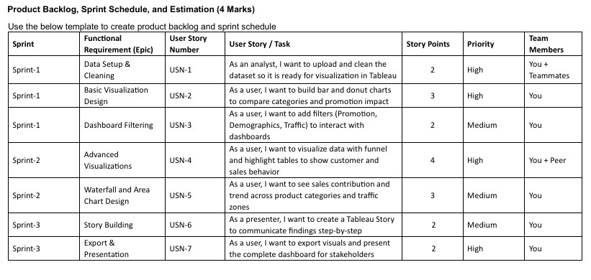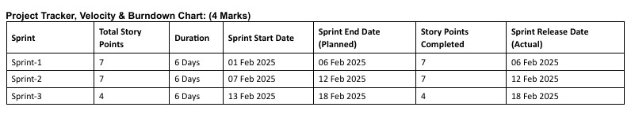

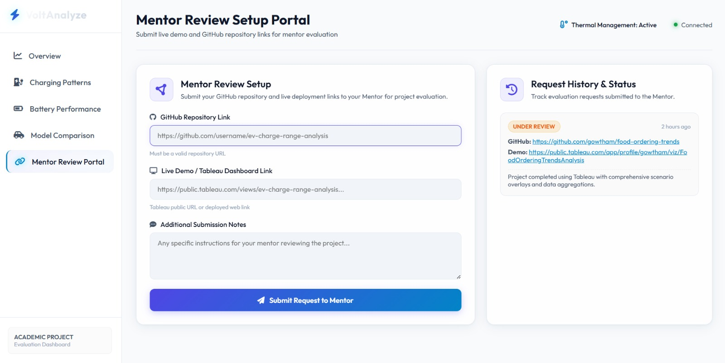
- PERFORMANCE TESTING :
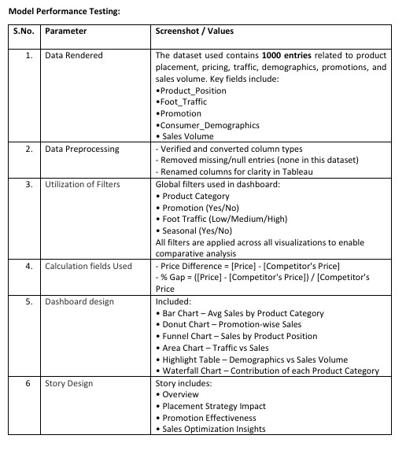

- RESULTS :
  - Output Screenshots:

- ADVANTAGES & DISADVANTAGES:

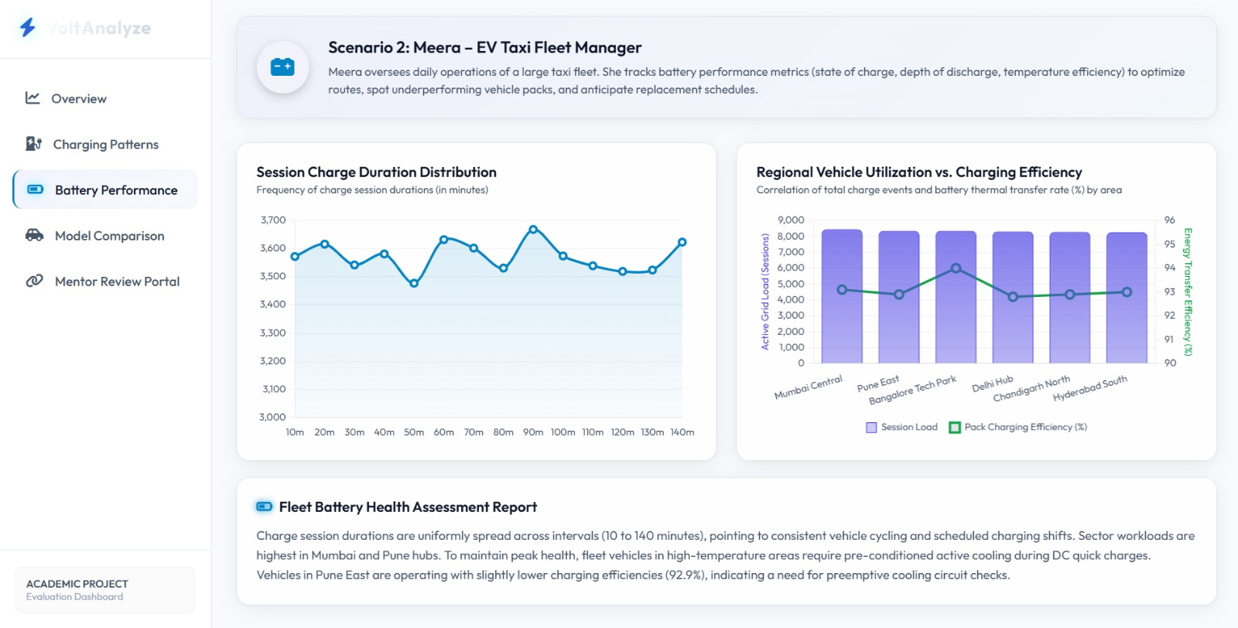
Advantages
Advantage | Description
1. Easy to  Understand & Use | Tableau dashboards offer intuitive drag-and-drop interactivity, making it user-friendly even for non-technical stakeholders.
2. Actionable Visual  Insights | Real-time filters and visuals allow retail decision-makers to analyze sales trends across product positions, promotions, and customer segments quickly.
3. Data-Driven  Decision-Making | Replaces guesswork and assumptions with clear, evidencebased insights drawn from actual store data.
4. Customization &  Flexibility | Users can filter data by demographics, traffic, promotion, and more, tailoring insights to specific goals.
Advantage | Description
5. Visual Storytelling | The Tableau Story feature allows presentation of insights in a logical, narrative format ideal for stakeholder presentations.
6. Low Cost &  Lightweight Setup | Uses publicly available tools (Tableau Public and CSV files) without requiring complex infrastructure or expensive licenses.
7. Scalable Design | The solution can be scaled easily to include new branches, time periods, or additional product lines with minimal architectural changes.

Disadvantages
Disadvantage | Description
1. Static Data Source | Since the dataset is CSV-based, it lacks real-time data updates. Manual uploads are required for each update cycle.
2. No Predictive Capabilities | The current solution is descriptive, not predictive. It identifies patterns but doesn’t forecast future trends.
3. Limited Automation | Without integration to live data sources (e.g., APIs, databases), it cannot support automated, continuous data refresh.
4. Requires Tableau  Familiarity for Editing | While the dashboard is easy to use, editing charts or building new visuals requires knowledge of Tableau.
5. No Backend Storage for  Historical Dashboards | Tableau Public does not support complex versioning or change-tracking unless hosted in Tableau Cloud/Server.
- CONCLUSION:

This project, Strategic Product Placement Analysis Using Tableau, successfully demonstrates how retail data — when visualized effectively — can uncover meaningful insights that directly impact sales performance and customer engagement.

By transforming a static dataset (Product Positioning.csv) into a fully interactive and filterable Tableau dashboard, the project empowers retail stakeholders to:
    - Identify which product placements result in the highest sales.

    - Understand the impact of promotional strategies across traffic zones and customer demographics.

    - Compare pricing with competitors and explore how these differences affect conversion.

    - Highlight trends that were previously hidden in spreadsheets or traditional static reports.

The dashboard offers an easy-to-use, visually intuitive interface that supports real-time filtering, multiple chart types (e.g., funnel, donut, bar, waterfall), and a narrative story to present findings effectively. It has proven to be an essential decision-support tool for: • Retail managers planning shelf layouts

    - Marketing teams optimizing promotions

    - Analysts identifying patterns in customer behavior

Through structured project planning, sprint-based execution, and iterative design, the solution met all key objectives:
    - Enhanced data visibility

    - Improved decision-making speed

    - Reduced reliance on manual reports
While there are limitations — such as the static nature of the data and absence of predictive analytics — the foundation laid in this project is robust, extensible, and provides a strong base for advanced analytics in the future.

In conclusion, the project validates that visual data storytelling using Tableau is a powerful enabler for smarter, customer-focused retail strategies.

- FUTURE SCOPE:

1. Real-Time Data Integration
    - Integrate live sales feeds from Point-of-Sale (POS) systems, Google Sheets, or retail databases.
    - Use Tableau’s live data connection features or APIs to update dashboards automatically without manual intervention.

2. Predictive Analytics and Machine Learning
• Incorporate machine learning models (using Python or R) to:
        - Predict which product placements are likely to generate higher conversions.
        - Forecast sales based on traffic and seasonal trends.
• Integrate clustering to group similar customer behaviors for segmentationbased strategies.

3. Cloud Deployment for Collaboration
    - Host the dashboard on Tableau Cloud or Tableau Server to enable enterprise-wide collaboration and access.
    - Allow different teams (marketing, sales, inventory) to view, interact, and draw conclusions from the same source of truth.

4. Deeper Segmentation and Personalization
    - Enhance filters with time of day, weekday vs. weekend, or specific customer personas.
    - Add more granular demographic categories (e.g., income level, age group breakdown) for highly targeted marketing insights.

5. Historical Data Versioning
    - Implement historical comparison features (e.g., month-over-month, yearover-year sales).
    - Add toggle options to compare past promotions and layout strategies for long-term analysis.

6. Dashboard-as-a-Service Model
    - Offer this Tableau dashboard as a commercial SaaS product for small-tomedium retailers.
    - Provide custom versions with client-specific branding and integrated customer data.

- APPENDIX:

      - Dataset Link - https://docs.google.com/spreadsheets/d/1kWb3PGyJVvbIWDD5VX7nOiT2s5DqQg gJ/edit?usp=sharing&ouid=112547506593735435883&rtpof=true&sd=true

      - GitHub – https://github.com/priyanshu8768/Strategic-ProductPlacement-Analysis.git

      - Project Demo Link - https://drive.google.com/file/d/1eFmVcDuSdcsFQBOfPxQc74qc3kO2A IG0/view?usp=sharing

